Name:___________________________________ Date:________________ P:______

The vertices of eight polygons are given below. For each Polygon:
- Plot the points in the coordinate plane and connect the points in the order that they are listed.
- Color the shape the indicated color
- Identify the type of polygon it is on the lines below.
- For some shapes find the area of each shape (Unit = cm²)

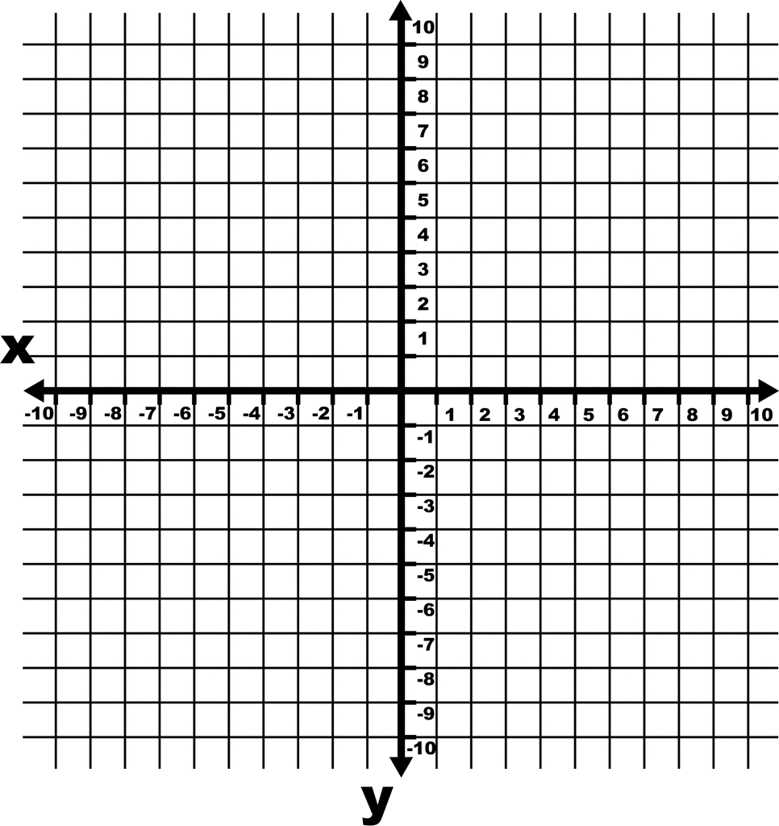
- The first polygon is RED and has these vertices (-7,4) (-8,5) (-8,6) (-7,7) (-5,7) (-5,5) (-7,4)
- The second polygon is ORANGE and has these vertices (-2,-7) (-1,-4) (3,-1) (6,-7) (-2,-7)
- The 3rd polygon is GREEN and has these vertices (4,3) (3,3) (2,2) (2,1) (3,0) (4,0 )(5,1) (5,2) (4,3)
- The fourth polygon is BROWN and has these vertices:(0,−10)(0,−8)(7,−10)(0,−10)
- The fifth polygon is PURPLE and has these vertices:(−8,−5)(−8,−8)(−5,−8)(−5,−5)(−8,−5)
- The sixth polygon is PINK and has these vertices:(9,−1)(6,1)(6,−3)(9,−1)
- The seventh polygon is BLUE and has these vertices:(−6,−4)(−6,1)(−9,1)(−9,−4)(−6,−4)
- The eighth polygon is YELLOW and has these vertices:(−5,1)(−3,−3)(−1,−2)(0,3)(−3,3)(−5,1)

1._______________ Area: ________
2. _______________Area: ________
3. _______________Area: ________
4. _______________Area: ________
5. _______________Area: ________
6. _______________Area: ________
7. _______________Area: ________
8. _______________Area: ________

Answers

- The red polygon is a hexagon.
- The orange polygon is a quadrilateral.
- The green polygon is an octagon.
- The brown polygon is a triangle.
- The purple polygon is a square.
- The pink polygon is a triangle.
- The blue polygon is a rectangle.
- The yellow polygon is a pentagon.
There are many ways to find the areas of the polygons. One way is to break each one up into triangles and rectangles. Here is one way to do that: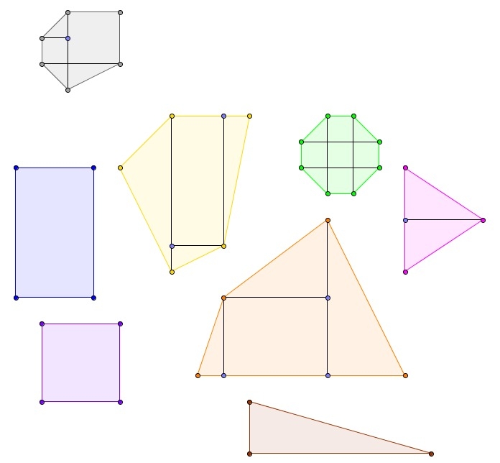
- The red polygon has an area of 7 square units.
- The orange polygon has an area of 28.5 square units.
- The green polygon has an area of 7 square units.
- The brown polygon has an area of 7 square units.
- The purple polygon has an area of 9 square units.
- The pink polygon has an area of 6 square units.
- The blue polygon has an area of 15 square units.
- The yellow polygon has an area of 19.5 square units.

